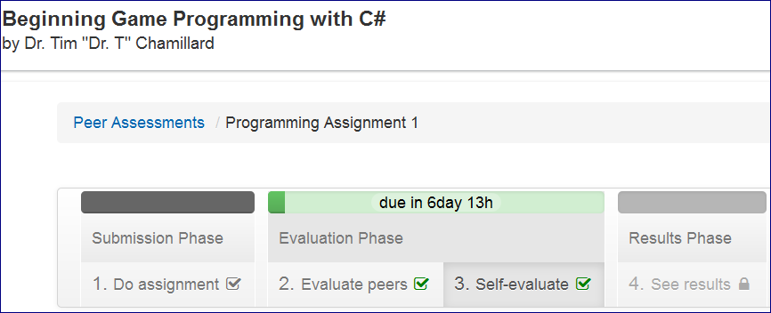

int gold;

float hours, min, gldPerMin;

Console.WriteLine("Hello, this application will calculate your average gold-collecting performance");

Console.Write("\n\nThe total gold you have collected in the game : ");

gold = int.Parse(Console.ReadLine());

Console.Write("Total Number of hours you have played : ");

hours = float.Parse(Console.ReadLine());

min = (hours * 60); //for hour to minute conversion

gldPerMin = (gold / min); //for gold per minute statics

Console.WriteLine("\n\nCollection of gold is " + gold +

"\nTotal playing Hours are " + hours +

"\nGold per Minute statics " + gldPerMin);

--==================

//declare integer constant

const int MINUTES_PER_HOUR = 60;

// display messages and read the input values

Console.WriteLine("Welcome! This application calculates your average gold collection!");

Console.Write("Your total gold collected in the game: ");

int gold = int.Parse(Console.ReadLine());

Console.Write("Your total hour played the game: ");

float hour = float.Parse(Console.ReadLine());

// calculate and display result

float minutes = hour * MINUTES_PER_HOUR;

float goldPerMinute = gold / minutes;

Console.WriteLine("You become {0} gold in {1} hours; the average is {2} gold/minute", gold, hour, goldPerMinute);